3. An example of harnessing Terrestrial Laser Scanner for remote sensing of saturation of chosen building materials
Czesław Suchocki¹, Jacek Katzer²
¹ Koszalin University of Technology, Faculty of Civil Engineering Environmental and Geodetic Sciences, Koszalin, Poland, orcid.org/0000-0002-0121-5711
² Koszalin University of Technology, Faculty of Civil Engineering Environmental and Geodetic Sciences, Koszalin, Poland, orcid.org/0000-0002-4049-5330

3.1. Introduction
Multiple Non Destructive Testing (NDT) methods are commonly used in civil and structural engineering. The most popular are NDT methods associated with structure safety checks. In case of concrete and concrete structures long-established and most popular NDT methods are rebound hammer test (also known as a Schmidt hammer or a Swiss hammer) and ultrasonic pulse velocity test (ASTM C597-02, 2002), (Katzer and Kobaka, 2009). These NDT methods are focused on assessing mechanical properties (predominantly compressive strength) of a particular material or a whole structure. There are NDT methods (e.g. inductive assessment) used worldwide for rebar reinforcement detection . One can also utilize X-ray computed tomography to determine 3D spacing of steel fibre and air pores in a concrete element (Ponikiewski et al., 2015). All these methods are associated with mechanical properties and they require direct access to the tested element or structure. Other properties of building materials than strength were so far of lesser interest in case of developing NDT methods. Structural safety, especially of old and historic buildings apart from pure strength characteristics of the used materials depends heavily on their saturation. Old structures are prone to being saturated due to lack of proper maintenance, deterioration of insulating materials, long lasting bad weather conditions, newly erected extensions, badly conducted restorations etc. Saturation significantly influence the performance of building materials both in strength and thermal aspects. In majority of cases the most vulnerable areas of such buildings are difficult or impossible to access without erecting full size scaffolding. The number of old buildings waiting for technical assessment is rapidly growing every year and clearly a new approach to NDT in civil and structural engineering is needed. Keeping these facts in mind authors decided to conduct a research programme focused on remote laser scanning of building materials. The main objective of the research programme was to prove that it is possible to use commercially available geodetic Terrestrial Laser Scanners (TLS) for quick and remote saturation assessment of building materials.

3.2. Theoretical background
The technique of remote measurement using a laser and the generation of multiple measurements in one scan procedure has been known since the 1980s of the 20th century (Marshall, 1985), (Blais, 2004). The collected data for each single scan point (vertical angle ϕ , horizontal angle ϑ, distance r between scanner and object) and a relative intensity of the signal as captured by the scanner are used to construct a digital model. The two- or three-dimensional model can be then used for a wide variety of geodetic applications. A scheme of geometric data collected during TLS test is presented in Fig. 3.1. Apart from geometric data TLS registers a relative intensity of the signal.

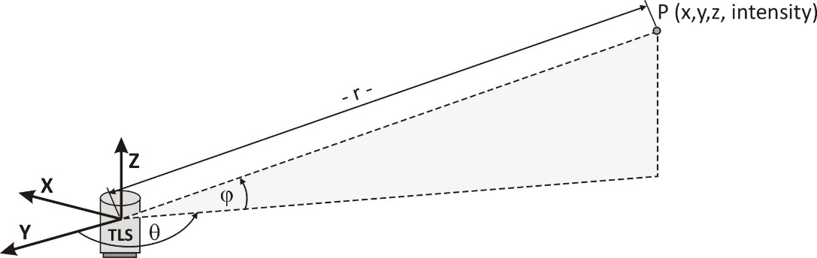

Fig. 3.1. Geometric data collected during TLS test
The surface characteristics influences the redistribution of the monochromatic laser light. When the surface of an object is smooth enough specular scattering occurs. In this case a ray of light will be bounced by a smooth shiny surface (e.g. mirror, polished metal). The angle of reflection is then equal to the angle of incidence and no signal will return to the scanner. The only exception is the situation when the object is scanned with a laser beam perpendicular to the object surface. When the surface is rough enough (opaque) the so-called Lambertian scattering occurs. In this case a ray of light is reflected equally in all directions. Different cases of Lambertian scattering are presented in Fig. 3.2.

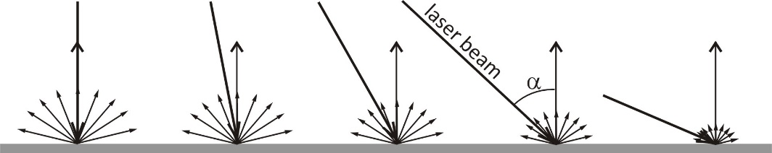
Fig. 3.2. A ray of light reflected from a rough surface (Lambertian scattering)
Mathematical notation of Lambertian scattering (Lambert’s cosine law) is as follows:
<Tab> Equation <Tab> (No)
$I\left(α\right)=I_{n}\cos{α}$ (3.1)
Where:
I(α) | – | the radiant or luminous intensity of the surface element in a direction at an angle α from the normal to the surface,
I_{n} | – | the radiant or luminous intensity of the surface element in the direction of the normal.
Lambertian scattering will take place during tests of majority of building materials. Only metal surfaces are smooth enough to bounce the laser signal. Mortar, plaster, concrete, ceramic, silica etc. all are characterized by rough surfaces giving Lambertian scattering while being hit by light beam. The relation between emitted and received laser signal while using TLS is described by the “laser equation” (Jelalian, A.V, 1992) - see eq. 3.2.

$P_{R}=\frac{πP_{E}ρ\cos{α}}{4r^{2}}η_{Atm}η_{Sys}$ (3.2)
Where:
P_{R} | – | detected signal power,
P_{E} | – | transmitted signal power,
α | – | angle of incidence,
ρ | – | reflectance of a material,
η_{Atm} | – | atmospheric transmission factor,
η_{Sys} | – | system transmission factor,
r | – | range.
The influence of different factors on scanning was proven by multiple researchers. The distance between TLS apparatus and the scanned object, the angle of a laser beam hitting an object and the very material of the object are the most important factors influencing scanning (Pfeifer et al., 2007), (Kaasalainen et al., 2009), (Pesci and Teza, 2008), (Previtali et al., 2014), (Previtali et al., 2014), (Barazzetti et al., 2015). So far TLSs were used for multiple geodetic and quasi-geodetic purposes like: deformation monitoring (Suchocki, Damięcka and Jagoda, 2008), structural assessment of bridges (Gordon et al., 2000), landslide monitoring (Suchocki, 2009), building façade measurement (Previtali et al., 2014) and monitoring of deflection of structures (Park et al., 2007).

3.3. Materials and methods
During the research programme an impulse TLS scanner VZ-400 produced by Riegl was utilized (see Fig. 3.3). This scanner uses a narrow infrared laser beam and a fast scanning mechanism. High-accuracy laser ranging is guaranteed by good echo digitization and online waveform processing. Laser pulse repetition is from 100 kHz to 300 kHz. Effective measurement rate varies from 42 000 meas/s to 122 000 meas/s. Measure range is from 1.5 m to 600 m. Laser wavelength is near infrared (700 nm - 1000 nm). Laser beam divergence is equal to 0.35 mm. The research programme was focused on commonly used (in EU countries) building materials such as ordinary concrete, cellular concrete, red ceramic and silica. Specimens were in a form of cubes and prisms. There were prepared three types of specimens: oven dry specimens, specimens saturated only by air humidity and fully saturated specimens. Detailed characteristics of used specimens are provided in Table 3.1.

Table. 3.1. Characteristics of tested
- Material | - Specimen shape | - Specimen type | - Dimensions [mm] | - Full saturation [%]
- Cellular concrete | - Prism | - Wall block | - 240∙600∙240 | - 52.6
- Silica | - Prism | - Wall hollow block | - 230∙120∙200 | - 16.5
- Red ceramic | - Prism | - Wall hollow block | - 375∙250∙240 | - 20.4
- Ordinary concrete | - Cube | - - | - 150∙150∙150 | - 1.1

Specimens were remotely scanned by terrestrial laser scanner from three different distances of 27m, 17m and 7m. These distances were chosen as representing a typical range for indoor building acquisition. A small building with overall dimensions smaller than 14m “in diameter” (2·7m=14m) do not require laser scanning. In such structures all internal surfaces are easy to reach and check. Very large buildings with chambers characterized by dimensions significantly larger than 54m in “diameter” (2·27m=54m) are rare. Due to the size of the laboratory in which the research programme was realized, it was impossible to conduct scanning from further distances.

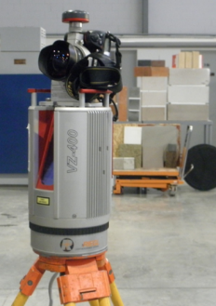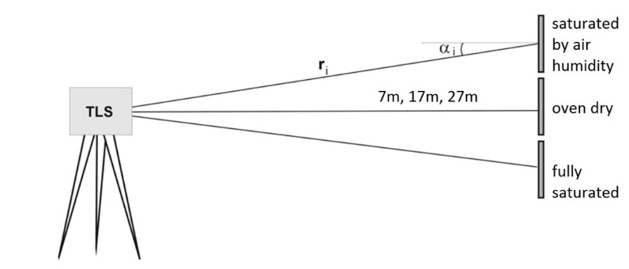
Fig. 3.3. Used TLS apparatus and setup of conducted tests
The measurement setup was realized in an indoor environment (temp. +20°C±1°C; r.h. 45%±1%) thus atmospheric transmission factor (η_{Atm}) would be constant for all conducted tests (see eq. 3.2). The tests were conducted indoor because saturation of walls, floors and other internal elements of a building is always a sign of bad performance or technical failure. On the other hand saturation of facades and roofs does not manifest obvious civil engineering problems. All tests have been carried out during days (indoor scattered light) to eliminate the influences of incidental lighting conditions. One can assume that in such stable test conditions and reasonably short time of scanning, the system transmission factor (η_{Sys}) and transmitted signal power (P_{E}) would be constant, too (see eq. 3.2). For the scanning distance of 7m the angle of observation α was equal to 0˚±3˚(see Fig. 3.3.). Keeping in mind that cos0˚=1 and cos3˚=0.9986 the angle of observation did not influence the scanning. In case of distances of 17m and 27m the angle of observation was much smaller and equal to 0˚±1˚ (cos1˚=0.9998) and 0˚±0.1˚ (cos0.1˚≈1.0000) respectively. In this way one can assume that the only factor from equation 2 which is still a variable is ρ (reflectance of a material). During the conducted tests the value of intensity of reflected laser beam was followed and registered. The intensity is directly associated with reflectance of a material and can be expressed as follows:

$Intensity=ρ⋅C$ (3.3)

Where:
ρ | – | reflectance of a material,
C | – | unknown constant.
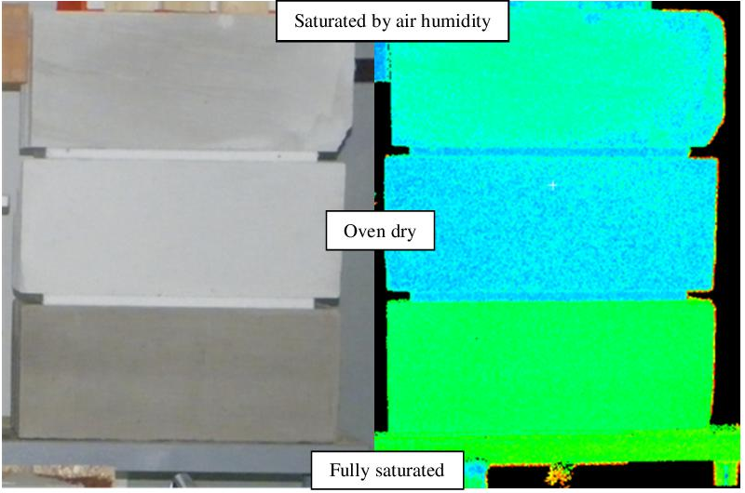
Fig. 3.4. Images of specimens of cellular concrete created by TLS during the test
The intensity of reflected laser beam was registered in multiple points of a given specimen. During the research programme the TLS apparatus was always set to the maximum scanning definition. Thus the number of points n where laser beam hit the specimen and returned to the apparatus was only depending on the distance from one to another. In case of utilized measurement setup the smaller the distance the larger the resolution of scanning. The value of n was ranging from 884 to 86307. The smallest value of n was achieved for the smallest specimen (a concrete cube) and the longest testing distance of 27 m. The highest number of testing points was achieved for the largest specimen (a cellular concrete wall block) and the shortest testing distance of 7 m. All values of n with corresponding test distances are presented in Table 3.2.

3.4. Achieved results and discussion
After conducting scanning all acquired data was filtered to remove digital noise and edge effects. Using RGB data, values of intensity and geometric coordinates (X,Y,Z), the sets of images were created. The values of intensity are registered by TLS in scale from -2047 to +2048. These values were recalculated to the fit scale from 0 to 1, which is most commonly used while presenting results of intensity. In Fig. 3.4. such exemplary images of specimens of cellular concrete are presented. There were always created pairs of images: the first was a traditional colour photo of tested specimens, the second was an image created with the help of artificial colours to visualize the values of the intensity registered by the TLS.
- Table 3.2. Number of tested points n and values of intensity | - Oven dry | - Cellular concrete | - Intensity | - range | - 0.095 | - 0.075 | - 0.147 | - Silica | - 0.058 | - 0.065 | - 0,13 | - Red ceramic | - 0.103 | - 0.076 | - 0.159 | - Ordinary concrete | - 0.168 | - 0.202 | - 0.199
 |  |  |  | - avg. | - 0.796 | - 0.798 | - 0.799 |  | - 0.801 | - 0.792 | - 0.785 |  | - 0.827 | - 0.803 | - 0.842 |  | - 0.553 | - 0.592 | - 0.602
 |  |  |  | - max. | - 0.846 | - 0.851 | - 0.867 |  | - 0.845 | - 0.831 | - 0.858 |  | - 0.880 | - 0.856 | - 0.905 |  | - 0.644 | - 0.697 | - 0.694
 |  |  |  | - min. | - 0.751 | - 0.776 | - 0.720 |  | - 0.787 | - 0.766 | - 0.730 |  | - 0.777 | - 0.780 | - 0.746 |  | - 0.476 | - 0.495 | - 0.495
 |  |  | - n |  | - 5975 | - 14428 | - 82514 |  | - 2872 | - 7222 | - 40502 |  | - 3575 | - 9892 | - 54102 |  | - 936 | - 2518 | - 14057
 | - Saturated by air humidity |  | - Intensity | - range | - 0.148 | - 0.139 | - 0.171 |  | - 0.095 | - 0.099 | - 0.137 |  | - 0.094 | - 0.093 | - 0.142 |  | - 0.130 | - 0.139 | - 0.183
 |  |  |  | - avg. | - 0.748 | - 0.765 | - 0.744 |  | - 0.783 | - 0.787 | - 0.788 |  | - 0.816 | - 0.802 | - 0.830 |  | - 0.608 | - 0.647 | - 0.653
 |  |  |  | - max. | - 0.811 | - 0.823 | - 0.846 |  | - 0.826 | - 0.816 | - 0.851 |  | - 0.859 | - 0.856 | - 0.890 |  | - 0.683 | - 0.708 | - 0.762
 |  |  |  | - min. | - 0.663 | - 0.684 | - 0.675 |  | - 0.731 | - 0.717 | - 0.714 |  | - 0.765 | - 0.763 | - 0.748 |  | - 0.553 | - 0.569 | - 0.579
 |  |  | - n |  | - 5975 | - 14428 | - 82514 |  | - 2845 | - 7047 | - 41247 |  | - 3460 | - 9744 | - 54544 |  | - 970 | - 2618 | - 14457
 | - Fully saturated |  | - Intensity | - range | - 0.097 | - 0.129 | - 0.134 |  | - 0.106 | - 0.108 | - 0.115 |  | - 0.103 | - 0.087 | - 0.126 |  | - 0.240 | - 0.374 | - 0.240
 |  |  |  | - avg. | - 0.607 | - 0.644 | - 0.642 |  | - 0.630 | - 0.658 | - 0.648 |  | - 0.745 | - 0.761 | - 0.738 |  | - 0.512 | - 0.525 | - 0.588
 |  |  |  | - max. | - 0.639 | - 0.689 | - 0.697 |  | - 0.684 | - 0.712 | - 0.697 |  | - 0.789 | - 0.794 | - 0.812 |  | - 0.606 | - 0.760 | - 0.683
 |  |  |  | - min. | - 0.542 | - 0.560 | - 0.563 |  | - 0.578 | - 0.604 | - 0.582 |  | - 0.686 | - 0.707 | - 0.686 |  | - 0.366 | - 0.386 | - 0.443
 |  |  | - n |  | - 6291 | - 15735 | - 86307 |  | - 2761 | - 7186 | - 41142 |  | - 3845 | - 9864 | - 54123 |  | - 884 | - 2470 | - 13804
 | - Distance[m] |  |  |  | - 27 | - 17 | - 7 |  | - 27 | - 17 | - 7 |  | - 27 | - 17 | - 7 |  | - 27 | - 17 | - 7
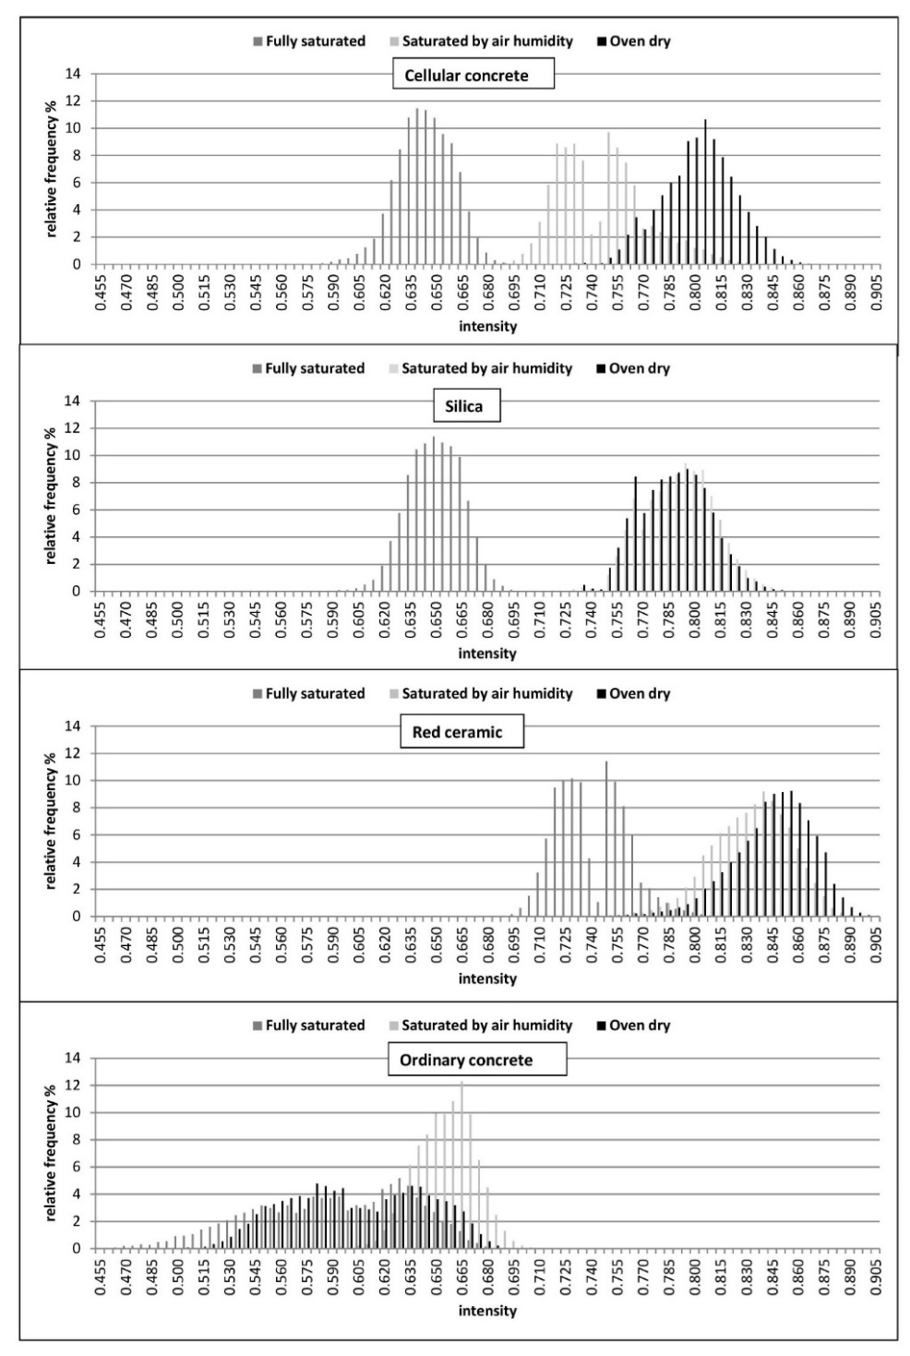
Fig. 3.5. Histograms of Intensity for all tested materials in three states of saturation (distance 7m)
Apart from images the whole sets of results associated with intensity were recorded. In Table 3.2. the minimum, maximum and average values of intensity measurements are presented for specific tested materials and their saturation. One also has to take into account that in harnessed measurement setup the shorter the distance between the apparatus and the specimen, the larger the number of tested points n. Therefore the better accuracy of modelling of scanned objects is very likely to be achieved.
Full sets of available data for distance of 7m were used to create the histograms presented in Fig. 3.5. Due to a different number of testing points n for different specimens the relative frequency of results was used as a scale for vertical axis. The horizontal axis is scaled in values of intensity without denomination. The range of the horizontal scale of all histograms was uniformed to enable easy comparison and analysis. In case of three out of four tested materials, there are clearly visible differences in values of intensity between fully saturated, saturated by air humidity and oven dry specimens. Only in case of ordinary concrete all results from one dense population of results. The histogram of cellular concrete is characterized by three separate peaks for three saturations. Results of silica and red ceramic specimens are characterized by two separate peaks. In both cases peaks for fully saturated material are clearly visible. The other peak consists of results of saturated by air humidity and oven dry specimens. It is useful to compare these results with the full saturation percentage by weight (see Table 3.1) of all four materials. Ordinary concrete is characterized by the smallest full saturation equal to 1.1%.
On the other hand the cellular concrete is characterized by the largest full saturation which is equal to 52.6% and almost 48 times larger than saturation of ordinary concrete. The achieved results prove that ordinary concrete is unsuitable for TLS saturation tests. This phenomenon is partially caused overall very small (in comparison to other tested materials) full saturation and partially by grey colour of the surface what influences the quality of scanning. The colour of the concrete surface is not uniform and varies in different areas. These variations are magnified by saturation level which eventually gives the dense overlapping populations of results for all three tests. In case of silica and red ceramic the overlapping of oven dry results and results for specimens saturated only by air humidity, can be explained by relatively small saturation by air humidity. The dense structure of these materials is not prone to easy saturation by air. Thus the results for oven dry state and “air humidity state” are directly overlapping. Even the “shape” of the both populations (achieved relative frequency for any given intensity) are very similar. The very high absorptivity of cellular concrete enabled the successful following all three saturation states. Saturation by air humidity is clearly visible because cellular concrete easily absorbs humidity from the air. This absorption is uniform throughout the surface of the element giving clear population of the results which is clearly different from the population of oven dry results. It would be beneficial for future research programme to take into consideration other than 45% humidities of the air. Conducted research programme proves that there is a potential of harnessing TLS for distant and NDT testing of saturation of building materials and whole erected structures. There should be conducted additional tests allowing better calibration of the technology for this specific and unconventional purpose.

3.5 Conclusions
The conducted research programme allows to draw the following conclusions:
- It is possible to assess saturation of building materials using TLS
- Quality of achieved results depends on tested material
- The bigger the maximum saturation the better quality of achieved results
- The research programme should be repeated using a larger number of specimens, different saturation levels and additional building materials

References
ASTM C597-02 (2002) ‘Standard Test Method for Pulse Velocity Trough Concrete’, Annual Book of ASTM Standards, pp. 3–6. doi: 10.1520/C0597-09.
Barazzetti, L. et al. (2015) ‘Bim from laser clouds and finite element analysis: Combining structural analysis and geometric complexity’, in International Archives of the Photogrammetry, Remote Sensing and Spatial Information Sciences - ISPRS Archives, pp. 345–350. doi: 10.5194/isprsarchives-XL-5-W4-345-2015.
Blais, F. (2004) ‘Review of 20 years of range sensor development’, Journal of Electronic Imaging, 13(1), p. 231. doi: 10.1117/1.1631921.
Gordon, S. et al. (2000) ‘Metric performance of a high-resolution laser scanner’, International Society of Optics and Photonics, 4309, pp. 174–184. doi: 10.1117/12.410872.
Jelalian, A.V (1992) Laser Radar Systems.
Kaasalainen, S. et al. (2009) ‘Topographic and Distance Effects in Laser Scanner Intensity Correction’, Proceedings, Laserscanning, Paris, France, , 1–2 September, 38, pp. 219–223.
Katzer, J. and Kobaka, J. (2009) ‘Combined non-destructive testing approach to waste fine aggregate cement composites’, Science and Engineering of Composite Materials, 16(4).
Marshall, G. (1985) Laser Beam Scanning: Opto-Mechanical Devices, Systems, and Data Storage Optics. Marshall.
Park, H. S. et al. (2007) ‘A new approach for health monitoring of structures: Terrestrial laser scanning’, Computer-Aided Civil and Infrastructure Engineering, 22(1), pp. 19–30. doi: 10.1111/j.1467-8667.2006.00466.x.
Pesci, A. and Teza, G. (2008) ‘Effects of surface irregularities on intensity data from laser scanning: An experimental approach’, Annals of Geophysics, 51(5–6), pp. 839–848. doi: 10.4401/ag-4462.
Pfeifer, N. et al. (2007) ‘Investigating terrestrial laser scanning intensity data: Quality and functional relations’, 8th Conference on Optical 3-D Measurement Techniques, pp. 328–337.
Ponikiewski, T. et al. (2015) ‘X-ray computed tomography harnessed to determine 3D spacing of steel fibres in self compacting concrete (SCC) slabs’, Construction and Building Materials, 74, pp. 102–108. doi: 10.1016/j.conbuildmat.2014.10.024.
Previtali, M. et al. (2014) ‘Automatic façade modelling using point cloud data for energy-efficient retrofitting’, Applied Geomatics, 6(2), pp. 95–113. doi: 10.1007/s12518-014-0129-9.
Suchocki, C. (2009) ‘Application of terrestrial laser scanner in cliff shores monitoring | Zastosowanie skanera naziemnego w monitorowaniu brzegów klifowych’, Rocznik Ochrona Srodowiska, 11(1).
Suchocki, C., Damięcka, M. and Jagoda, M. (2008) ‘Determination of the building wall deviations from the vertical plane’, in 7th International Conference on Environmental Engineering, ICEE 2008 - Conference Proceedings.

